Software Engineering Semester Project

Project name: Home interior furniture website

1. **Introduction**

**KKWOODTECH** is a dynamic and innovative company specializing in the production and distribution of high-quality wood products. In order to enhance its online presence and provide a seamless experience for customers, the **KKWOODTECH** website project aims to create a modern, user-friendly, and informative platform.

The website will visually showcase **KKWOODTECH's** diverse range of wood products in an appealing and comprehensive manner. It will emphasize the unique features, quality, and sustainability aspects of each product. The goal is to provide visitors with a detailed understanding of the craftsmanship and excellence that define **KKWOODTECH's** offerings.

Additionally, the website will incorporate some static data that can only be added by the owner. This includes databases and admin panels to efficiently respond to user requests and post pictures. These features will contribute to a dynamic and interactive user experience, allowing customers to explore the products and engage with the brand seamlessly.

1. **Objective**

The **KKWOODTECH** website aims to create a modern, user-friendly platform that visually showcases a diverse range of high-quality wood products. It emphasizes unique features craftsmanship, sustainability, engaging visitors and providing a seamless, enjoyable customer experience. Serving as an informative hub, the site educates users about **KKWOODTECH's** products, highlighting craftsmanship, quality, and sustainability. Interactive features, including static data and admin panels, ensure efficient owner responsiveness and dynamic content updates, enhancing overall user engagement.

1. **Problem Description**

**What:**

The KKWOODTECH website project aims to develop a visually appealing and user-friendly online platform that showcases the company's diverse range of high-quality wood products. The website will serve as an interactive hub, highlighting the unique features, craftsmanship, and sustainability aspects of each product. It incorporates static data, allowing the owner to efficiently respond to user requests and update product information. The project includes the creation of databases and admin panels for seamless management.

Why:

The project is of significant value as it addresses the need for a modern and informative online presence in the wood product industry. In an increasingly digital world, a well-designed website is crucial for brand promotion, customer engagement, and business growth. The KKWOODTECH website will provide customers with an immersive experience, educating them about the superior quality and sustainability of the wood products. This, in turn, enhances brand credibility and attracts a wider customer base. The static data and admin panels ensure timely updates, keeping the content fresh and relevant.

**Target Domain:**

The project targets the wood product industry, specifically catering to consumers, architects, interior designers, and construction professionals seeking high-quality wood solutions. The platform's comprehensive product showcase and emphasis on sustainability are particularly beneficial for eco-conscious consumers and professionals looking for premium wood materials with unique features.

**Benefits to the Target Domain:**

The target domain benefits from the **KKWOODTECH** website through:

* **Information Accessibility:** Professionals and consumers can easily access detailed information about the wood products, aiding informed decision-making in construction and design projects.
* **Brand Credibility**: The website enhances **KKWOODTECH's** brand credibility by transparently showcasing the craftsmanship and sustainability aspects, attracting customers who prioritize these factors.
* **Efficient Communication**: The admin panels and static data facilitate efficient communication, allowing the owner to promptly respond to inquiries, update product details, and post the latest pictures, ensuring a dynamic and engaging online presence.

1. **Features**

**Product Showcase:**

* Visually appealing display of KKWOODTECH's high-quality wood products.
* Detailed product pages highlighting specifications, features, and sustainability.

**User-Friendly Interface:**

* Intuitive navigation for a seamless user experience.
* Responsive design for compatibility across devices.

**Information Hub:**

* Comprehensive content providing insights into craftsmanship, quality, and sustainability.

**Static Data Integration:**

* Owner's capability to add and update static data, including product details.

**Admin Panels:**

* Dedicated admin panels for efficient management of user inquiries and product updates.
* User-friendly interface for easy navigation and data input for admins.

**Database Integration:**

* Database system for storing and managing dynamic content.
* Seamless integration for real-time updates.

**Visual Appeal:**

* High-resolution images and multimedia for an engaging visual experience.
* Consistent branding for KKWOODTECH's identity.

**Interactive Features:**

* User engagement tools such as inquiry forms.
* Contact forms for customer inquiries.

1. **Users**

The users involved in this website are only:

* Admin
* Users

1. **Requirements**

The requirements for this system involves the:

* 1. User
     1. User friendly environment
     2. Easy to navigate
     3. Contact with admins easily
  2. Admins should update the content of page timely.
  3. Quick response to user inquiries.
  4. Quick response to the user requests on project quotations.

1. **References**

1.The “Get a quote” button’s idea was taken from the Interwood’s website. As it was a very good approach for users to request for the quotation of the given product.

**Phase 1:**

1. **Functional Requirements**
   1. Admin is needed.
   2. Static data should be displayed on.
   3. The information of user will be saved.
   4. The modal and contact queries should be answered quickly.
   5. The buttons should work properly.
2. **Non-Functional Requirements**
   1. The website should be responsive.
   2. The colors and UI/UX should be according to the client requirements.
   3. It should be responsive for all types of devices.

**Functional Requirements Description**

* Functional requirements describe the specific functions and features that a system must have in order to meet the needs of its users.

|  |  |  |  |  |
| --- | --- | --- | --- | --- |
| **ID #** | **Function Name** | | **Functional Requirement Description** | **Software Requirement** |
| FR 1 | | Admin Panel Management | The system must provide a dedicated admin panel for efficient management of user inquiries and product updates. Admins should be able navigate the admin interface, and update the content of the website in real-time. | The system should include an intuitive admin interface, and the capability to edit and update static data, including product details. |
| FR 2 | | Data Display | The website should display static data, including product details, craftsmanship insights, and sustainability information. The static data must be easily accessible to users for a comprehensive understanding of KKWOODTECH's wood products. | The system should incorporate a user-friendly interface that visually showcases static data, allowing users to navigate and explore detailed information about the wood products. |
| FR 3 | | User information Stage | The information entered in modal for the ‘Get a quote’ and the contact form should be saved in the database and this is the most important functional requirement if the admin wants to retrieve the data from the database the database should be the able to give the data stored. And to reply to the queries of the user data should be present. | The main software requirement or this is that your software should be easy to understand and the software should be in the language which is mainly easy to understand by the ADMIN first and then the person who is using the admin to enter and retrieve the data. |

**Non-functional Requirements Description**

* Non-functional requirements, on the other hand, describe the performance, usability, and other non-functional characteristics of a system.

|  |  |  |  |
| --- | --- | --- | --- |
| **ID #** | **Function Name** | **Non-Functional Requirement Description** | **Software Requirement** |
| NFR 1 | Performance | The system should respond to user actions within 2 seconds for routine tasks. The system should support at least 100 simultaneous users without significant performance degradation. | Front-end optimization, caching mechanism. |
| NFR 2 | Security | Access to sensitive information should be restricted based on user roles.  **Data Encryption:** All sensitive data transmitted over the network should be encrypted using industry-standard protocols. | The system should provide a way to manage user roles and permissions. |
| NFR 3 | Data management | Regular backups of critical data should be performed, and a recovery plan should be in place.  Define policies for data retention and deletion to comply with legal and regulatory requirements. | Implement an automated backup system to regularly and consistently back up critical data at scheduled intervals. Use secure deletion algorithms to permanently remove sensitive or personally identifiable information from the system. |

**Constraint Requirements Description**

* Constraint requirements are a type of requirement that specifies a limitation or restriction on the behavior or performance of a system. These requirements are used to ensure that a system meets certain standards, regulations, or other constraints that are imposed on it.

|  |  |  |  |
| --- | --- | --- | --- |
| **ID #** | **Function Name** | **Constraint Requirement Description** | **Software Requirement** |
| CON1 | Budget Constraints | The website development must adhere to the allocated budget, considering expenses related to design, development, hosting, and ongoing maintenance. | Open source software, free development tools, Content management system (Word press) |
| CON2 | Timeline Constraints | The website must be developed and launched within the agreed-upon timeframe, considering factors such as design approval, content creation, and testing phases. | Collaboration and Communication Tools like Discord, Slack, Teams. |
| CON3 | Scalability Constraints | The website should be designed to accommodate potential future growth in terms of user traffic, content volume, and additional features. | Host website on scalable cloud platform like AWS, Microsoft Azure, google cloud platform |

**Domain Requirements Description**

|  |  |  |  |
| --- | --- | --- | --- |
| **ID #** | **Function Name** | **Domain Requirement Description** | **Software Requirement** |
| Dom1 | Domain Requirement: | The system must support the management of a comprehensive product catalog, including details such as product specifications, images, and pricing. | Implement a PIM system to centralize and manage product information efficiently. |
| Dom2 | Customer Relationship Management (CRM): | The system must include CRM functionalities to manage customer interactions, track customer preferences, and provide personalized services. | Develop or integrate an order processing system to manage customer orders, order status, and shipment tracking. |
| Dom3 | Order Processing and Inventory Management: | The system must facilitate order processing and inventory management to track product availability, manage stock levels, and fulfill customer orders. | Implement a CRM software solution to store and manage customer data, including contact information, purchase history, and preferences. |

DIAGRAMS:

## Use Case diagram:

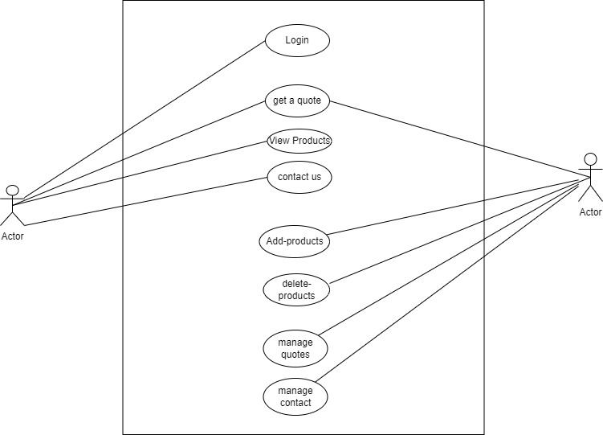

ADMIN

USER

**Use Case Description: Add-Products**

Primary Actor: Admin

Stakeholders: None

Preconditions: Admin has to be logged in.

Post Conditions: None

Trigger: Admin decides to add a new product to website.

Main Success Scenario:

1. Admin navigates to the 'Add Products' section.

2.Admin inputs the necessary product details such as name, description, price, and category.

3.Admin clicks the 'Add Product' button.

4. The system verifies the entered details and displays a confirmation message upon successful addition of the product.

**Extensions:**

1a. If the customer is not logged in, the system will prompt the customer to log in.

1b. If the admin does not have an admin account, the system will notify the admin that he/she cannot add products.

1c. If the product details are incomplete or invalid, the system will display an error message.

**Step-by-step flow:**

**Admin->Add Products Section->Enter Product Details->Add Product Button->System Verification>Success Confirmation**

# Use Case: View Products

Primary Actor: Customer

Stakeholders: None

Preconditions: Customer has to be logged in.

Post conditions: None

Trigger: Customer decides to view products on website.

***Main Success Scenario:***

1. Customer navigates to the 'View Products' section.
2. The system displays the products along with their details.

**Extensions:**

1a. If the customer is not logged in, the system will prompt the customer to log in.

1b. If the customer does not have a seller account, the system will notify the customer that he/she cannot view products.

1c. If the system encounters an error while retrieving the products, the system will display an error message.

**Step-by-step flow:**

Customer->View Products Section->System Retrieval->Product Display

# Use Case: Get a Quote

Use Case Description:

Primary Actor: Customer

Stakeholders: None

Preconditions: Customer has to be logged in.

Post conditions: None

Trigger: Customer decides to get a quote for a product.

**Main Success Scenario:**

1. Customer navigates to the 'View Products' section.
2. Customer selects a product.
3. Customer clicks the 'Get a Quote' button.
4. The system generates a quote form and displays it to the customer.

**Extensions:**

1a. If the customer is not logged in, the system will prompt the customer to log in.

1b. If the system encounters an error while generating the quote, the system will display an error message.

**Step-by-step flow:**

**Customer->View Products Section->Select Product->Get a Quote Button->System Quote Generation->Quote Display**

# Use Case: Delete Products

Use Case Description:

Primary Actor: ADMIN

Stakeholders: None

Preconditions: ADMIN has to be logged in and must have a seller account.

Post conditions: None

Trigger: ADMIN decides to delete a product from his/her seller account.

**Main Success Scenario:**

1. Admin navigates to the 'View Products' section.
2. Admin selects a product.
3. Admin clicks the 'Delete Product' button.
4. Admin confirms the deletion.
5. The system deletes the product and displays a success message.

**Extensions:**

1a. If the admin is not logged in, the system will prompt the admin to log in.

1b. If the admin does not have a admin account, the system will notify the customer that he/she cannot delete products.

1c. If the admin does not confirm the deletion, the system will not delete the product.

1d. If the system encounters an error while deleting the product, the system will display an error message.

**Step-by-step flow:**

**Customer->View Products Section->Select Product->Delete Product Button->System Confirmation**

**Prompt->Customer Confirmation->System Product Deletion->Success Confirmation**

## Class Diagram:

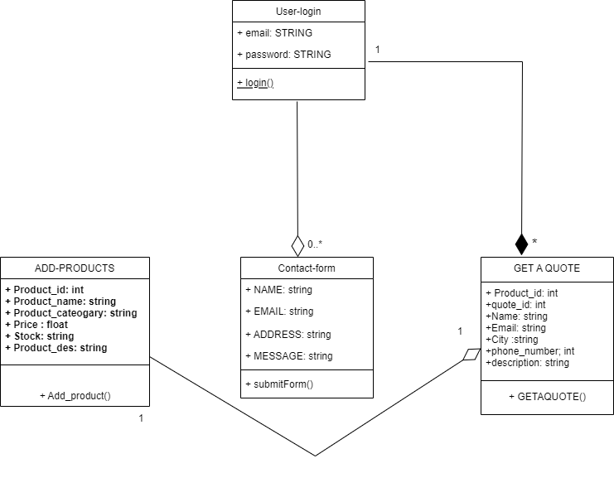

## Sequence Diagram:

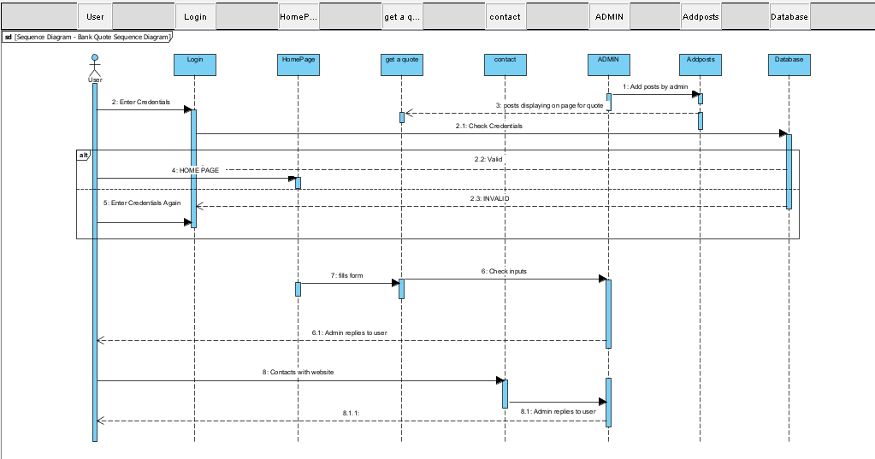

## Activity diagram

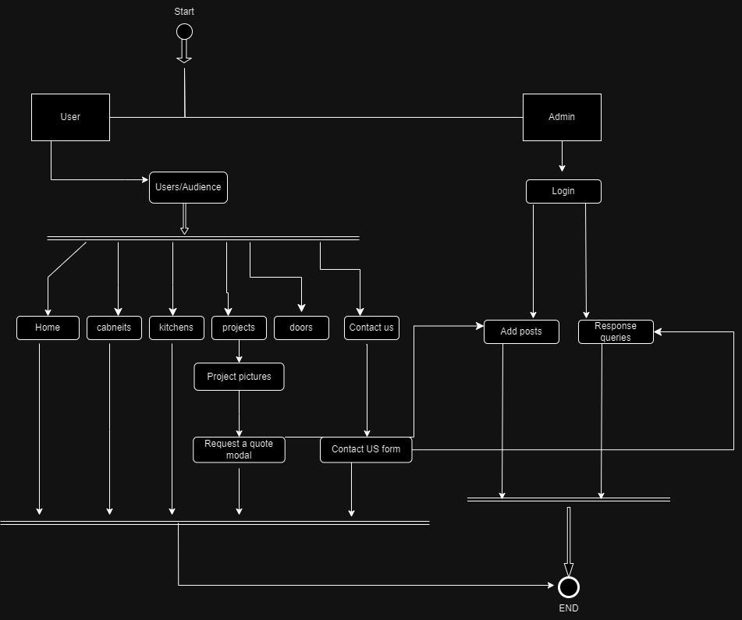

## Architecture Diagram:

A three-tier architecture diagram is a type of architecture diagram shows the main components of a system organized into three layers: the presentation layer, the application layer, and the data layer.

The presentation layer is the top layer of the three-tier architecture diagram. It is responsible for handling the user interface and presenting the data to the user. The presentation layer typically includes the web browser, the user interface code, and the user interface components.

The application layer is the middle layer of the three-tier architecture diagram. It is responsible for processing the data and performing the business logic of the system. The application layer typically includes the web server, the application code, and the application components.

The data layer is the bottom layer of the three-tier architecture diagram. It is responsible for storing and retrieving the data that is used by the system. The data layer typically includes the database, the database code, and the database components.

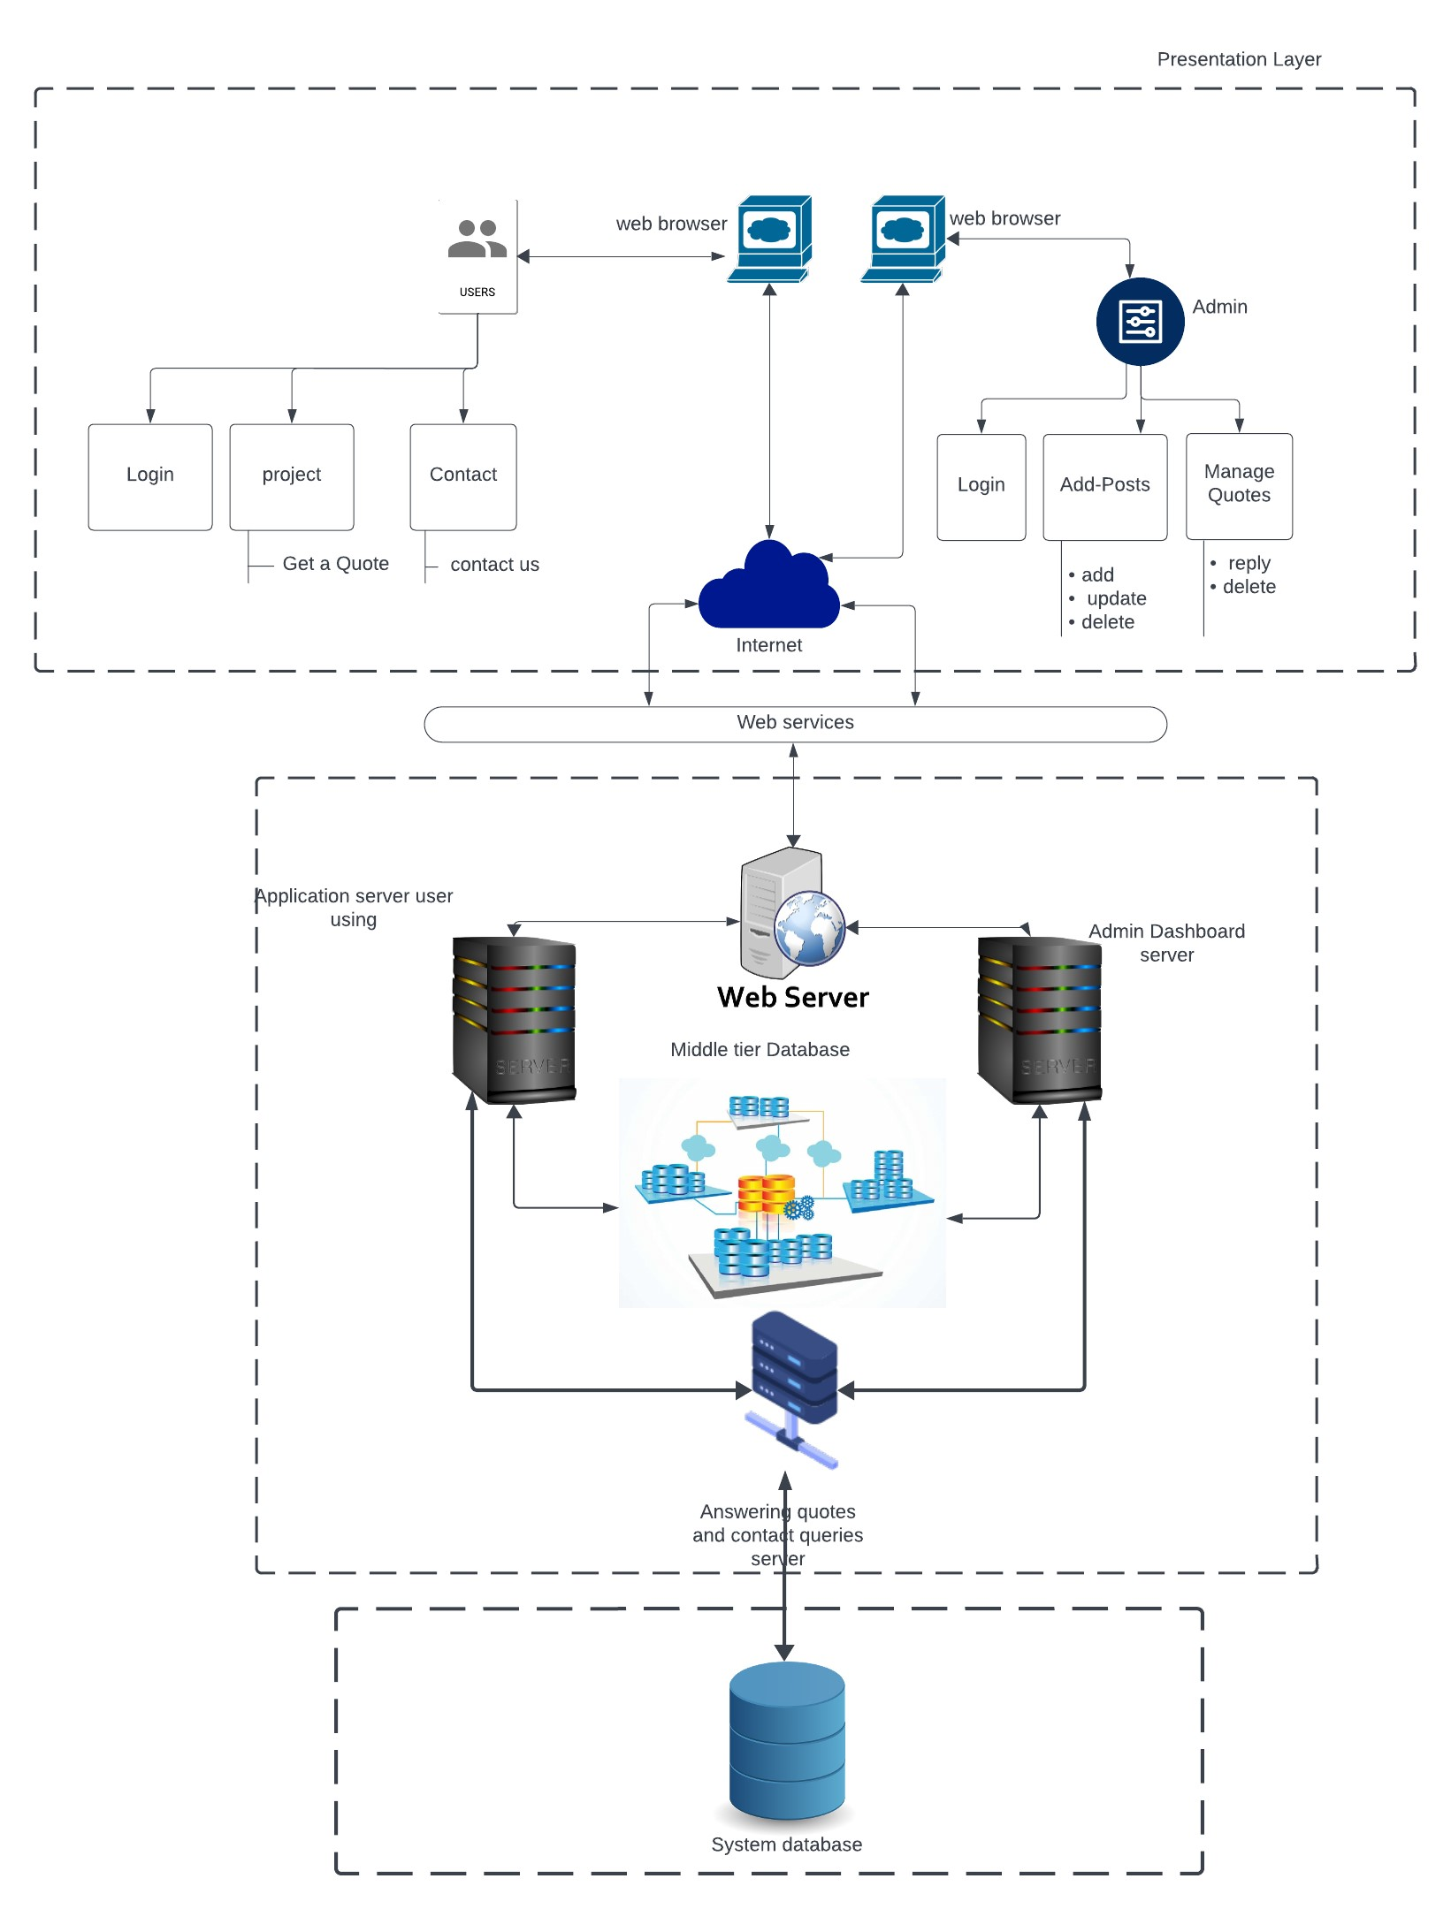

Data layer

logical layer